To: Metro Planning Department Staff: Director Lucy Kempf, Anita McCaig, Logan Elliott

Metro Fire Chief and Emergency Management Agency Director for Davidson County: Director William Swann

Metro Stormwater and Floodplain management: Tom Palco, Roger Lindsay

Metro Parks: Director Monique Odom, Greenways Director Cindy Harrison

Mayor’s Office: Sustainability Chief, Kendra Abkowitz

RE: Proposed Ariza apartments (471 units) on Harpeth- Bellevue Community Plan Amendment (2021CP-006-001)

Hello!

The Harpeth Conservancy would like to provide this information on floodwater depths and flooding public safety risks for Metro planning and other Metro department considerations regarding the proposed Bellevue community plan Amendment on the Harpeth in Bellevue for the proposed 471 unit Ariza apartments. Our organization has expertise in stormwater management, planning and land use as well as clean water law and regulation. We worked with the city of Franklin, the Army Corp or Engineers, and other experts recently on a very similar proposal for a high density development in a high flood risk area of the Harpeth in Franklin. In April the Franklin Board of Mayor and Aldermen unanimously turned down that proposed development in keeping with two similar votes by the Franklin Planning Commission. A primary concern was that floodwater depths on the main road in and out of that bend in the Harpeth was inundated with floodwaters at depths over 1 foot or more that posed real public safety risks. This is a very similar issue in this hairpin bend in the Harpeth in Bellevue as the maps and information show below.

Our organization has been involved in flood recovery and floodplain management policy for many years. The Harpeth Conservancy along with Metro Councilmember Courtney Johnson and Franklin Mayor Ken Moore are coalition members of [Flood Ready TN](https://floodreadytn.com/). This is a coalition of elected officials, homeowners, small business owners, faith leaders, and community members across the state dedicated to making Tennessee resilient against the frequent flooding. These proposals on the Harpeth in several jurisdictions as well as others around middle TN raise the broader policy issue of ensuring that public safety in the event of flooding are specifically evaluated during rezoning and related land use decisions.

We have worked with Metro for many years, including a major effort we developed across several counties including Davison to remove 100s of tons of flood debris after the May 2010 flood. We have were involved in the United Flood Preparedness Plan and stormwater management efforts in Nashville. Close to 20 years ago we worked with former metro Councilmember, Charlie Tygard, and former Greenways coordinator, Shain Dennison, to help finalize the Harpeth Greenway at the Morton Mill Old Harding terminus.

With this email below we will focus on flooding risks in this uniquely challenging and highly altered area of the Harpeth floodplain in Bellevue. We reached out to the Army Corp of Engineers who did a major update of the Harpeth River floodplain models after the May 2010 flood. Below are data and maps of floodwater depths from the Metro’s GIS floodplain database the Army Corp created for the Harpeth. Metro contracted with the Army Corp to do this major revision of the floodplain models and data layers across the county after the May 2010 flood.

I understand that Metro has recently contracted with the Army Corp to update key statistics (river flows and rainfall statistics) across Davidson county as part of an effort to incorporate the impact of climate change. This work will start this fall and will likely lead to updating floodplain models for the Harpeth. Also my understanding is that the work will also include some prediction of major storm events that this region is now experiencing as a result of climatic changes. This work will be very valuable in evaluating any proposed changes to current zoning, transect policy, other aspects of Nashville Next and subdivision regulations. It will be especially relevant to the Fussell property that is in this hairpin turn in the Harpeth.

1. Ariza Apartment proposal is in highly constrained area that supports current T2-RM policy versus the proposal to change to T3-NE:

The Proposed Ariza Apartments is on highly constrained property in a hairpin turn on the Harpeth river in Bellevue by the Bellevue soccer fields. (see image below from developer’s material). Flood prone areas surround this property (thought not all are shown in the image just below), and the CSX rail line and I-40 present other important constraints for emergency access. This property does not have an unconstrained ingress/egress that is out of flood prone zones much less having two unconstrained ingress/egress as would be required for the proposed land use policy change to T3-NE from the current T2- Rural Maintenance in the Bellevue Community Plan. We will send a separate email to Planning staff with further analysis in addition to these flood safety constraints that support maintaining the current T2- RM policy as the most appropriate for this property.

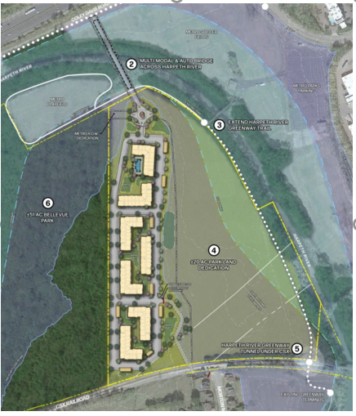

1. Public Safety during Flooding is a Significant Concern with this proposed Rezoning for a 471- apartment complex proposal:
   1. Nashville Weather Service-- Turn Around Don’t Drown- floodwater depths are above public safety guidance

The [National Weather service, Turn Around, Don’t Drown](https://www.weather.gov/tsa/hydro_tadd) campaign is very clear about floodwater risks. **Six inches of water will reach the bottom of most passenger cars and cause loss of control and possibly stalling. A foot of water will float most vehicles. Two feet of moving water can carry away most vehicles including SUVs and pick-up trucks.**

**The cost of emergency response is not fully recovered from disasters and puts emergency personnel at risk as well as the risks the loss of or damage to equipment.** [During the March 28, 2021 flood Metro lost a million dollar plus fire truck](https://www.firefighterclosecalls.com/nashville-ladder-truck-under-water-from-extreme-flooding-tennessee/) when it was responding to a flood call. The flood waters on Old Harding from the Harpeth were deep enough that the fire truck lost the ability to control the truck and the team had to abandon it.

Flood fatalities are the second leading weather-related cause of death after heat. Flood fatalities are predominantly from people driving into floodwaters, especially at night. Dr. John Walsh, Co- Program Director of Vanderbilt Program in Disaster Response and Training, has provided the city of Franklin with sources and details on these flood related disaster risks. His information is attached and below is his contact information and I have copied him on this email.

This is important to emphasize in light of the applicant response to questions from the 7/72022 public meeting that stated that “many residents in neighborhoods across the Nashville region would need to shelter in place” and that the Ariza buildings “will remain outside of the flood zone to provide refuge for our residents. “ This response misses the fundamental issue with public safety during flooding that Dr. Walsh, the National Weather Service and others point out-- of

all flood fatalities over the past 11 years (2010-2022), by far, the largest activity victims were performing was **“driving.”**

This development itself would put 471 residential households in a situation surrounded by floodwaters. This increases the likelihood of people driving through floodwaters. During the historic May 2010 flood, 3 people drowned in the Bellevue area near Morton Mill Road/Old Harding Pike.

John J. Walsh, Jr., Ph.D.

Co-Director, Program in Disaster Research and Training

Vanderbilt University Medical Center

615-322-1037

[john.walsh@vanderbilt.edu](mailto:john.walsh@vanderbilt.edu)

* 1. Floodwater depths are 3-3.5 feet on Coley Davis Road (main access) and 2-3 feet at Morton Mill/CSX RR (emergency access)

This area of the Harpeth is compromised by floodwaters and the CSX railroad during flooding not just at the close proximity to the proposed development but further away as well! The map below indicate 4 areas where flood waters inundate roads that hamper both access to the property directly as well as emergency access and response. The maps and data of depth of water on Coley Davis and Morton Mill are provided by Barry Moran, Hydraulic Engineer, for the Nashville District of the Army Corp. He led the project for Metro to update the current adopted floodplain maps in this area after the 2010 Flood. This information is from the Metro GIS maps.

This map was prepared by Harpeth Conservancy to show the 4 areas constrained by floodwaters.

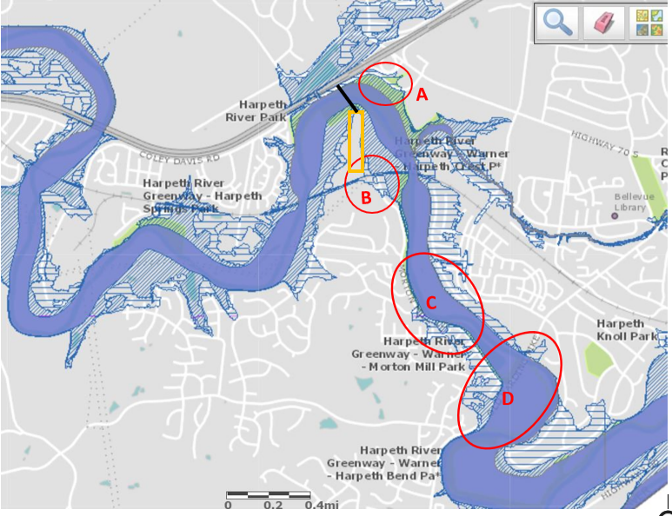

A— Primary access via new bridge across Harpeth River to Coley Davis Road. Flood waters 3.0-3.5 feet at 500-year floodplain elevation (0.2% probability annually). (See first PHOTO below)

B- Emergency access through CSX RR to Morton Mill dead end. Morton Mill inundated with 2-3 feet at 500-year floodplain elevation (See second PHOTO below)

We understand that during the May 2010 flood the RR bridge was compromised and trains have been stranded which block this emergency access.

C- Morton Mill Road inundated at 100-year floodplain.

D- Old Harding Pike inundated with Floodway. Area of Metro Fire Truck stranded during 2021 Flood.

Here is [drone video off Facebook from 2021](https://www.facebook.com/joey3078/videos/4275498262478967/) showing the flooding at Old Harding and Morton Mill where the fire truck was stranded.

This is the way into the Morton Mill area. This area is very constrained during a flood.

Below is the data and map provided by Barry Moran.

Coley Davis Road flood water depths: Green Point on map

* Water would be about 3 – 3.5 feet at green point shown during 500yr. 500yr Year Elev = 562.5 ft. at cross-section shown. Approximate elev at low point in sag of road El. 559 ft.
* Not flooded at 100 yr.
* About 1 ft of flooding for a 200yr flood event.

Depth of floodwaters at Morton Mill- emergency access area: Green Circle on map.

* Flood water depth 2 – 3 feet over roadways during 500yr. No flooding at 100yr and inches for 200yr.

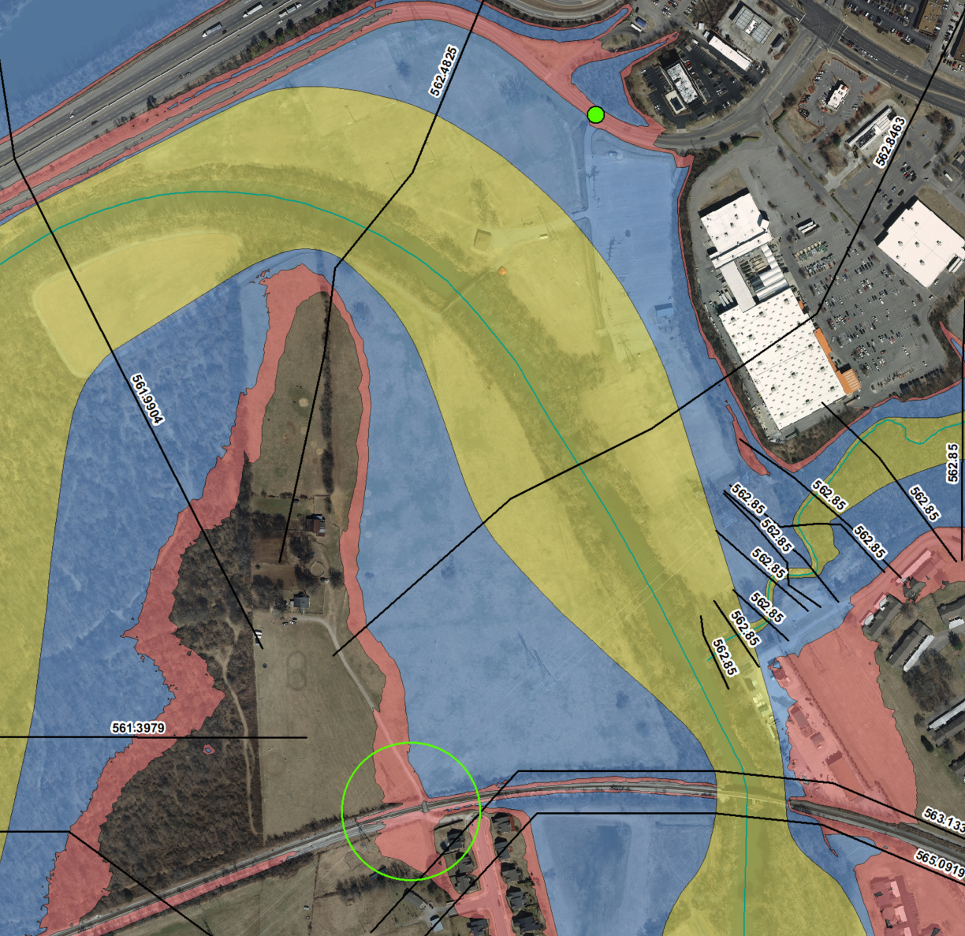

Notes for the map--

Green is the floodway—the main river channel during flooding.

Blue shows the 100-year floodplain (1% probability of flooding annually)

Red shows the 500-year floodplain (0.2% probability of flooding annually).

The black lines show the elevation for the 500-year floodplain.

* 1. New high density development needs to address current flood constraints for public safety and consider May 2010 flood

The May 2010 flood had an historic peak of 33.23 feet above the gage at Highway 100. This is about 7 feet ABOVE the 500 year flood elevation on the Army Corp maps above. With the flood risk in the area, it would be important to design the proposed bridge over the Harpeth with the May 2010 flood elevations so the bridge is accessible. Also the proposed development could address the current flood risk for all the residents, businesses and assisted living center on Coley Davis Road by elevating Coley Davis Road above the 500 -year floodplain.

With this high flood prone hairpin curve in the Harpeth, it would be important for any high density development to be based on the updated flow stats, rainfall stats and floodplain models that Metro has contracted the Army Corp to perform starting this fall. See number 4 below for details.

Flooding images:

Below is satellite imagery from [Nashville.gov of the May 2010 flood.](https://maps.nashville.gov/May2010Flood/) Coley Davis Road is south of I-40 running parallel. I-40 was inundated for a time period and floodwaters can be seen in this image.

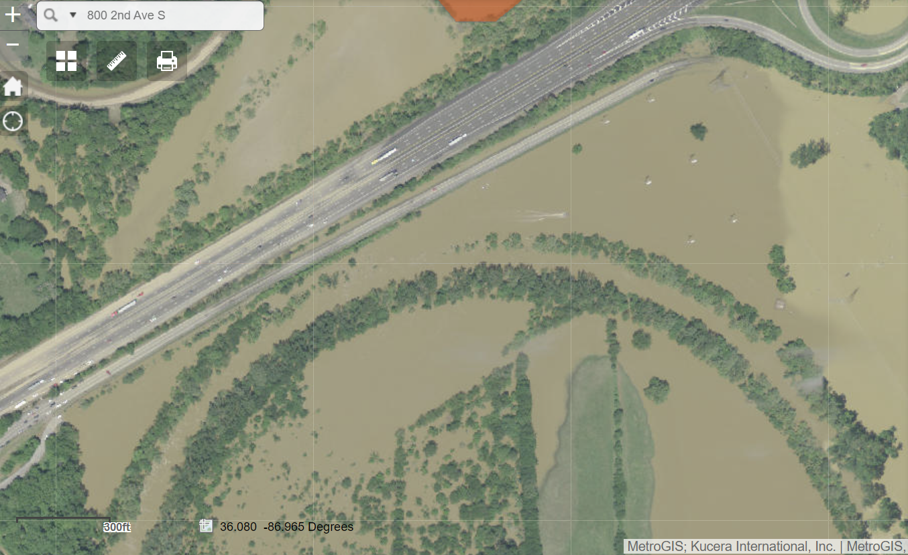

Coley Davis Road flooding image:

Flooding on Coley Davis road cuts off and isolates the 4 subdivisions, office park, retirement home, and TVA substation. The location of the proposed bridge for Ariza apartments would be affected as well. This photo was from flooding in May 2010.

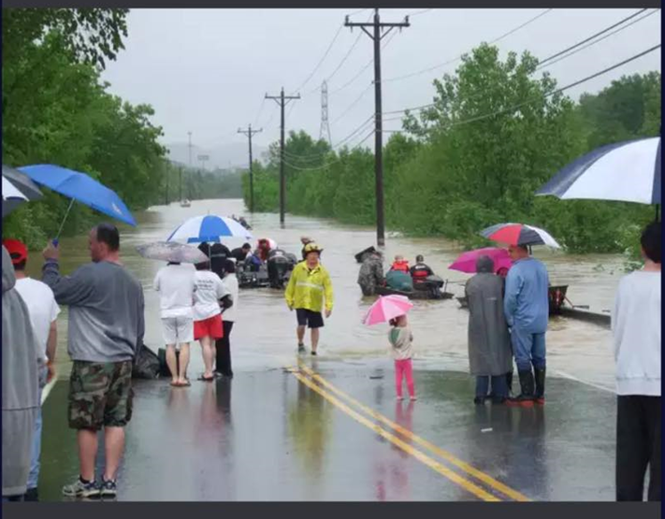

Morton Mill road/end where emergency access would be for Ariza:

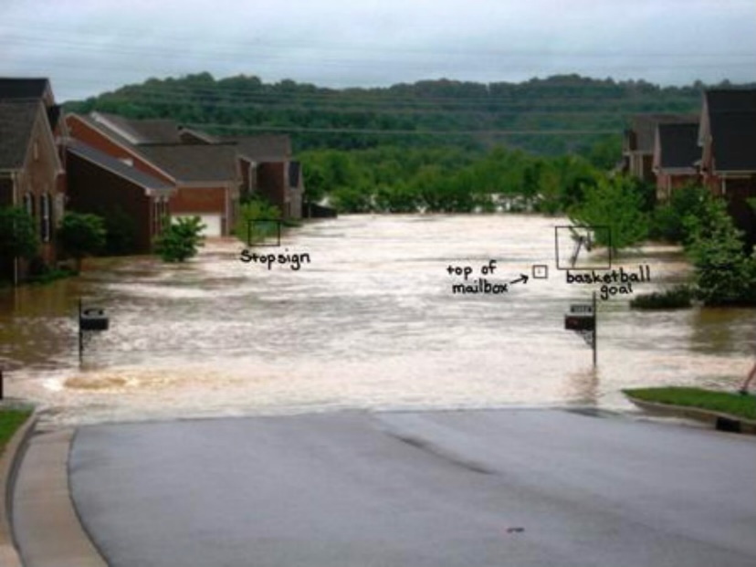

4. Climate change is driving increase in storm intensity and frequency not captured in current floodplain and stormwater models

Floodplain and floodway lines on maps mark probabilities, not permanent non-changing lines that floodwaters will not cross. Nashville is one of the country’s most at-risk inland cities for flooding. Severe storms are now more frequent and more intense. Rainstorms of 5 inches and higher have doubled in frequency in the Nashville area. In August 2021, the Waverly TN catastrophic flood set a new state record of over 17 inches. Computer models are not accounting for this changing weather intensity. This essentially results in underestimating the amount of water to manage for stormwater and cut and fill models for changes to the floodplain as well as floodplain probabilities.

As noted above, this is the impetus for the work Metro has contracted the Army Corp to do in updating river flow statistics and to do predictions of flooding with large rain events hitting specific rivers systems in the county.

The March 2021 flood (7+ inches) is now the second largest storm event in this area since the historic May 2010 flood, only 11 years ago. The May 2010 flood was created from two back-to-back large storms for a total of nearly 14 inches! The floodplain and stormwater models have a key assumption that there will be 72 hours, or a drying period of some standard length, between storms and rain events. When ground is saturated and rain events are frequent, the models under predict the volume of water and flood levels. Roger Lindsey, Metro Water Services staff, who is involved with the TN Floodplain Managers Association, provided a great overview with statistics at our May [Conservation Conversation in 2021](https://www.youtube.com/watch?v=wnLD9lR9BaE&t=280s) on flooding.

There are several key statistics that are the foundation of floodplain and stormwater models-- rainfall statistics and river flow statistics. Aaron Rogge, at CDMSmith, presented on the need to update rainfall statistics to the Franklin aldermen and planning commission about 1 and ½ years ago. He and other experts in the Army Corp, engineering consultant firms, and Metro staff point out that a key foundation of these models used for stormwater design and floodplain mapping are the rainfall statistics published by NOAA, the federal agency in which is the national weather service.

The NOAA tables are the rainfall statistics used for the “design storms” that are the basis of floodplain and stormwater design and regulations. These statistics were published in 2006, but go through 2004. This means the May 2010 flood, March 2021 flood, and the last 17 years of rainfall are not in the statistics. Aaron Rogge at CDMSmith provided us with outputs from their NetStorm link that runs the statistics and includes more recent data at the stations in Nashville used for the national statistics. What can be seen is that the larger storm events 5 inches in 24 hours) are now more frequent, doubling in frequency. The March 28, 2021, flood that resulted from the 8.6 inch 24-hour storm event in Nashville now has a recurrence frequency that has doubled.

Attached is a Tennessean story from march that specifically discusses the need to update rainfall statistics that quotes Metro Water Services staff, Roger Lindsey, myself and others.

Recent extreme storms that created new historic record flooding in St. Louis and Eastern Kentucky in late July reinforce what experts in stormwater and floodplain management have been pointing out—extreme rain events likes these, March 2021, and May 2010 are now over 4 times more likely than they were 20 years ago.

To close, this hairpin turn of the Harpeth in Bellevue is highly flood prone. Also the Harpeth River in Davidson county is the recipient of storm and flood flows from the upper third of the watershed that includes Williamson county, Franklin and Brentwood. In addition, this particular property that the Ariza apts is proposed for is highly constrained by the CSX railroad and I-40. In combination, this property does not have unconstrained ways in and out during major flood events. As a result, the current T2-RM policy that is in the Bellevue Community Plan is the most appropriate for this bend in the Harpeth.

Please feel free to contact us about any of this information. My contact information is below and you can also reach out to our COO and VP, Grace Stranch at [gracestranch@harpethriver.org](mailto:gracestranch@harpethriver.org), 615-498-4148.

Sincerely,

Dorie Bolze

|  |  |  |  |  |  |  |
| --- | --- | --- | --- | --- | --- | --- |
| [cid:image001.png@01D8A153.3AC3FD30](http://harpethconservancy.org/) |  | **Dorene Bolze** President/Chief Executive Officer  **Harpeth Conservancy** [215 Jamestown Park, Suite 101 Brentwood, TN 37027](http://maps.apple.com/?q=215%20Jamestown%20Park,%20Suite%20101,Brentwood,%20Tennessee,37027)   |  | | --- | | o) 615-790-9767 m) 615-479-0181 |   [HarpethConservancy.org](http://harpethconservancy.org)   |  |  |  | | --- | --- | --- | | [Facebook](https://facebook.com/HarpethRiver) | [Twitter](https://twitter.com/TheHarpethRiver) | [Instagram](https://instagram.com/harpethriver) | |